How to Correct Your Sitting Posture
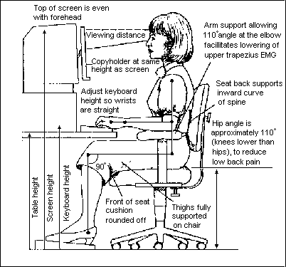
1. Keep your head in a neutral position and make sure the computer monitor is at eye level to reduce head flexion while working. The computer monitor should be about an arm’s length away. Make sure your work is directly in front of you so you are looking straight ahead.
2. Adjust armrest height to allow your shoulders relax while sitting. Try to avoid rotating them forward.
3. While adjusting the armrests, position your elbows close to your sides and bent at a 90 degree angle.
4. Keep your wrists in a neutral position, avoid bending them up or down. You may have to use a small towel or pad to achieve this position.
5. Adjust chair incline to maintain maximum contact with your back while sitting. If your chair isn’t adjustable, place a towel roll in the middle of your back for extra support.
6. If possible adjust seat height or use a foot rest to achieve 90 degrees of knee flexion and have both feet flat on the floor. This may also decrease excessive pressure on the low back.
At Work Stretches
For each stretch hold the position for 20-30 seconds 2 times.
Try to do each stretch once before lunch and once after.
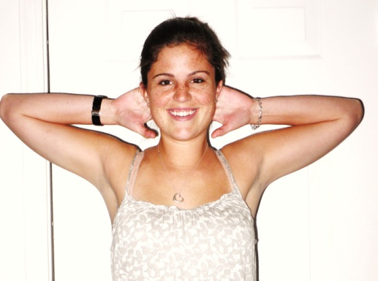 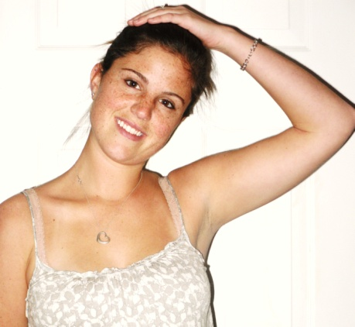
Chest Stretch - Place both of your hands on the back of your head and slowly push your elbow backwards.
Upper Trapezium - Tilt your head slightly in one direction. Place one hand on top of your head and one by your side. Apply light overpressure to your head.

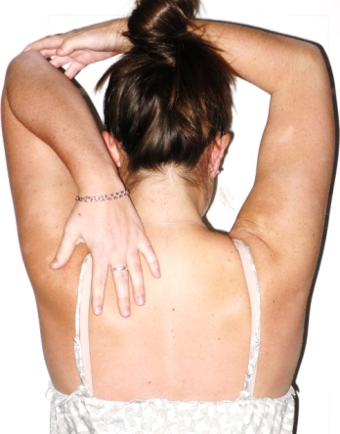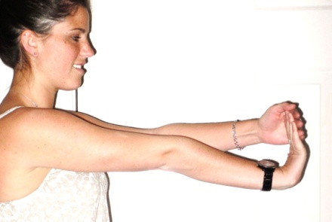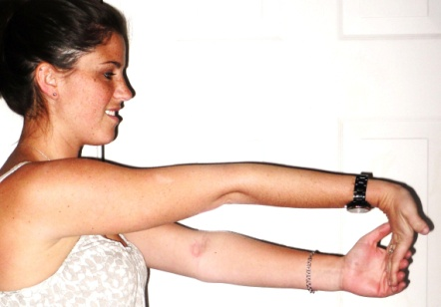
Wrist flexors/extensors - Straighten both arms out in front of you; flex your wrist with your fingers facing up. Grab these fingers with your other hand and apply a slight over pressure. Repeat this procedure with your fingers pointing down.

Triceps - Hold both arms directly over head. Bend one elbow to reach for your upper back, and place the other hand on that elbow for over pressure.

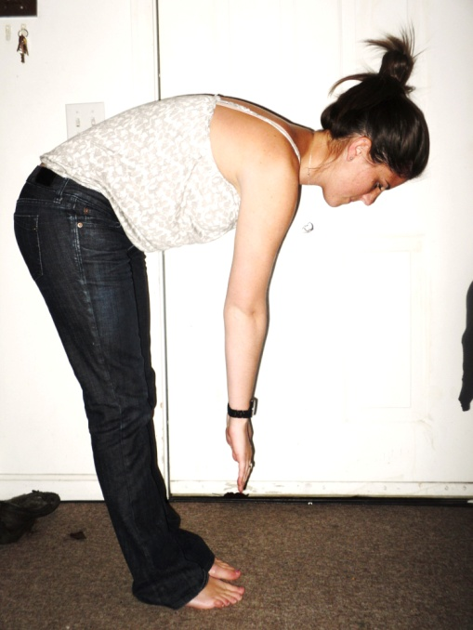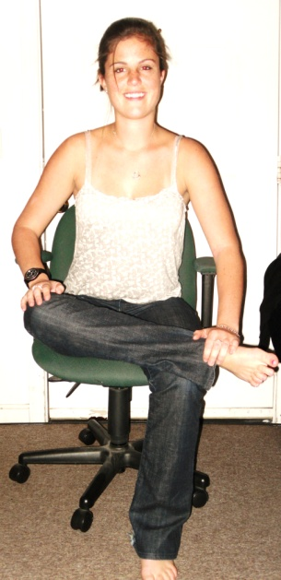
Cross one leg over the other as the picture shows. Place one hand on your foot and the other on your knee. Keep you back flat and bend slightly forward at your hips, you should start to feel a stretch in your buttocks.
Try to touch your toes! Keep your feet together, knees straight and don’t bounce.

