Lowering Your Cholesterol
Emerald Health and Wellness-Week 3
Today’s Objectives
- Define cholesterol and its components
- Explain what your lab values mean
- Provide tips to help improve or maintain your cholesterol

What is cholesterol and where does it come from?
- Cholesterol is a waxy, fat-like substance found in the blood and cell walls throughout the body.
- It is naturally produced by the body but is also obtained through foods you eat such as:
  - Whole milk dairy products
  - Egg yolks
  - Shrimp
  - Organ meats (liver)
- Cholesterol plays a role in vital day-to-day body functions including the production of:
  - Hormones
  - Bile acids
  - Vitamin D

If cholesterol helps with important body functions, than why is high cholesterol bad?
- Not all cholesterol is good.
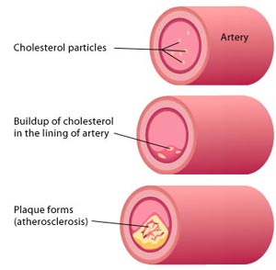
- Cholesterol is carried through the blood by 2 different transportation vehicles called lipoproteins.
  - Low density lipoproteins (LDL) carry cholesterol to body tissues and arteries.
    - Considered “bad” because when there are too many LDL’s in the blood, the extra cholesterol collects in the artery walls
    - This cholesterol buildup or plaque formation blocks blood flow and can lead to the development of heart disease
    - This is cholesterol buildup is shown in the picture on the right.
  - High density lipoproteins (HDL) transport cholesterol from the body tissues to the liver.
    - Considered “good” because the liver than removes the cholesterol from the body.
    - This decreases the amount of cholesterol in the blood and artery walls which decreases the risk of developing heart disease.

What are triglycerides and where do they come from?
- Most common type of fat in the body
- After you eat, a portion of your calorie consumption is used right away for body functions. The other “unused” portion of your calories is converted into triglycerides.
- These triglycerides are:
  - Stored in fat cells
  - Released for energy in between meals
  - Circulated in the blood
- High triglyceride levels can lead to:
  - Plaque formation within your arterial walls
  - Increased risk of atherosclerosis, stroke and heart disease
- Excessive alcohol, coffee drinks with flavored syrups (found at Starbucks and Dunkin Donuts), soda, and candy can quickly add to the buildup of triglycerides.

Lab Values
- The chart below shows the optimal levels for these lab values.
- We do request that you please talk to your doctor to assist with deciding where your individual target levels should be.

Lab Tests | Healthy Levels | What it all means
Total cholesterol | <200 mg/dL | Measures the total amount of cholesterol in your blood including both LDL and HDL cholesterols.  It is important to look at the breakdown of LDL and HDL that make up this number.
LDL  (Bad cholesterol) | <130 mg/dL | Most people should aim for a LDL level below 130 mg/dL, but if you have other risk factors for heart disease, you may need to aim for a LDL level below 100 or below 70 mg/dL.
HDL  (Good cholesterol) | >40 mg/dL | A low HDL level increases your risk for heart disease, so a desirable level of HDL is > 40 mg/dL.  However, the higher your HDL value is, the better and having a level >60 is protective against heart disease.
Total cholesterol/HDL | Men: < 5.0  Women: < 4.4 | The total cholesterol to HDL ratio compares the amount of “good” cholesterol and total cholesterol in your blood.  In general, the lower this number is, the better.
Triglycerides | <150 mg/dL | Triglycerides are a common type of fat that are circulated in your blood and stored in the body for extra energy.

Main things you can do to improve or maintain your cholesterol:
- Practice healthy diet habits
  - Week 2’s podcast gave you a large overview on healthy diet habits, but there are specific foods and nutrients you can focus on that effect your cholesterol.
  - Please see the next page of this document for more details on cholesterol friendly foods and habits.
- Participate in regular physical activity
  - At least 30 minutes of aerobic exercise per day, most days of the week
    - Minimum of 150 minutes/week
  - Examples of aerobic exercise include walking briskly, running, swimming, and biking
  - Following these guidelines can help raise your good cholesterol and lower your triglycerides. In fact, after just 2 months your HDL level may increase by 5%!
- Manage your weight
  - Being overweight or obese can cause high “bad” cholesterol levels and low “good” cholesterol levels.
  - Weight loss as little as 5 to 10 pounds may assist in lowering your “bad” cholesterol and triglyceride levels.
  - For every 6 pounds you lose, your “good” cholesterol may increase by 1 mg/dL.
  - These improvements in cholesterol help reduce your risk for developing heart disease.
- Quit smoking!
  - This could improve your good cholesterol by 10%!
- Limit your alcohol intake

Cholesterol Friendly Diet Tips
Remember: Your body produces all of the cholesterol that it needs for body functions. Therefore, what you eat and the nutrients that you take in through your diet greatly affect your cholesterol levels.

- 3 major nutrients in your diet that make your total and LDL cholesterol levels rise are: Saturated fats, Cholesterol and Trans fat.

Saturated Fat
Recommended Daily Intake | Generally:  <10% of your daily calories (<20 grams if you are following a 2,000 calorie diet)  To lower cholesterol, the Therapeutic Lifestyle Changes Program suggests:  <7% of your daily calories (<15 grams if you are following a 2,000 calorie diet)
Foods that contain high levels | Whole milk dairy products  Red meats  Butter  Plants oils (palm and coconut oils)
Substitutions and Suggestions to help lower your intake | Substituting leaner meats  - Eat poultry (chicken and turkey) or fish instead of red meat  - Remove skin from poultry  - If you must have red meat, choose leaner cuts and trim off the visible fat  - Lean cuts of beef include sirloin tip, round steak, and rump roast  - Lean cuts of pork include center cut ham, loin chops, and pork tenderloin  - Choose low or non-fat dairy products (milk, yogurt, cheese)  - Use olive, peanut or canola oil in salad dressings and when cooking  - These contain monounsaturated fats  - Replace the cheese or meat on your salad with a handful of walnuts.  - Nuts, such as walnuts and almonds, contain polyunsaturated fats and are a good substitution for foods high in saturated fat

Trans Fat
Recommended Daily Intake | 0% of daily caloric intake (0 grams if you are following a 2000 calorie diet)
Foods that contain high levels | Margarines, commercially baked goods, fried foods and other packaged foods  Note: Trans fats are made during food processing and help keep food fresh longer while it is on the grocery shelves. Although many companies now produce products that are “trans fat free”, they may still contain <0.5 grams of trans fat.
Substitutions and Suggestions to help lower your intake | Look at your nutrition labels and ingredients lists.  Only chose food products that have 0 grams of trans fat and do NOT have “partially hydrogenated oil” on the ingredients list.
Cholesterol
Recommended Daily Intake | Generally:  <300 mg per day  To lower cholesterol, the Therapeutic Lifestyle Changes Program suggests:  <200 mg per day
Foods that contain high levels | Whole milk dairy products  Egg yolks  Shrimp  Organ meats such as liver
Substitutions and Suggestions to help lower your intake | Low or non-fat dairy products  Egg substitutes or egg whites  Limit your intake of shrimp and organ meats

Cholesterol friendly substances you should add to your diet

- Soluble fiber: a type of dietary fiber found in certain foods.
  - A soluble fiber intake as part of a healthy diet should be 5-10 g/day.
  - Increasing your soluble fiber intake to 10-25 grams per day is recommended to help reduce your total and bad cholesterol levels.
  - Foods containing soluble fiber include oatmeal, barley, flaxseed, apples, pears, peas, carrots, citrus fruits and beans.
- Omega-3 Fatty acids
  - Can also help lower your bad cholesterol and triglyceride levels
  - Foods containing Omega-3 fatty acids include walnuts, almonds, flaxseed, and fish such as salmon, herring, and mackerel
- Sterols and stanols: substances found in plants that help block the absorption of cholesterol
  - Recommended 2 grams/day to lower bad cholesterol
  - Some companies have produced sterol or stanol fortified foods
    - Minute Maid Heart Wise orange juice
    - Promise active supershots yogurt drinks

For more information on the Therapeutic Lifestyle Changes (TLC) program, please see the excellent link to the TLC diet at the end of this podcast for detailed recommendations.

Check your knowledge
- Which of the following items will help lower your cholesterol?
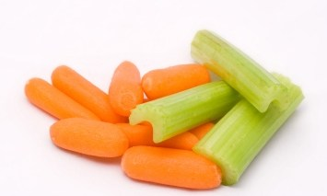
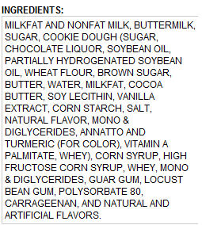
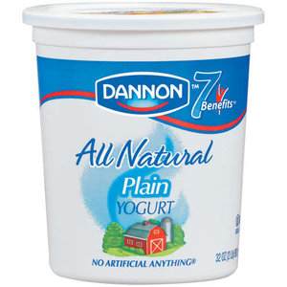

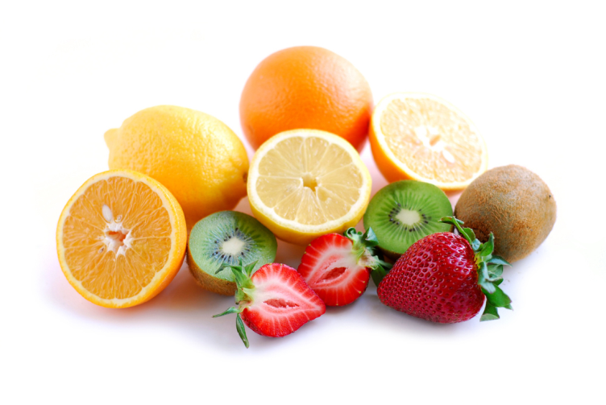

Answers…
- The carrots and celery, the fruit, and walking or running will help lower your cholesterol.
- The Dannon All-Natural Plain yogurt is a whole milk dairy product and has too much saturated fat and cholesterol. This should be substituted with low or non-fat yogurt.
- The ingredients list is for Hood Cookie Dough Ice Cream and one of the ingredients listed is “partially hydrogenated soybean oil” which is a trans fat. Anything with trans fat should be eliminated from your diet.

Challenge of the week!!
- Stock up your fridge with cholesterol friendly foods:
  - 1% or Skim Milk
  - Low fat or non fat yogurt and/or cheeses
  - Ground turkey or chicken instead of ground beef
  - Lots of fresh fruits and veggies
- Bonus: Add saturated fat and cholesterol to your food diary to track how much you consume each day

References
- Dash Diet
http://www.nhlbi.nih.gov/health/public/heart/hbp/dash/new_dash.pdf
- Centers for Disease Control and Prevention (CDC)
www.cdc.gov/nutrition/everyone/basics/fat/index.html
- National Heart Lung and Blood Institute (NHLBI)
www.nhlbi.nih.gov/health/health-topics/topics/hbc/
- Mayo Clinic
www.mayoclinic.com/health/reduce-cholesterol/CL00012
- TLC Program
http://www.nhlbi.nih.gov/health/public/heart/chol/chol_tlc.pdf

